

***PROJECT REPORT***

**On**

Arduino Gas & Smoke Detector

Course Code: CSE-423

Course Title: Embedded System

**Submitted To**

**Shuvo Das**

Department of CSE

Daffodil International University

***Submitted By***

**Md. Kawsar Hasan (161-15-6951)**

Date of Submission 05.08.2019

**Appartus:**

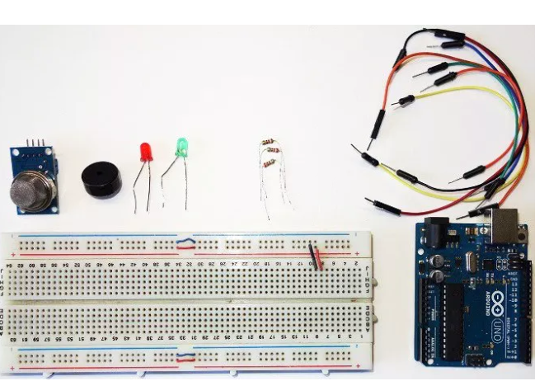

* **Arduino UNO.**
* **Breadboard.**
* **Wires.**
* **5 mm LED: Red.**
* **5 mm LED: Green.**
* **Buzzer.**
* **Resistor.**
* **MQ-2 Smoke Sensor.**

**Circuit Diagram:**



**Sketch:**

int redLed = 12;

int greenLed = 11;

int buzzer = 10;

int smoke = A0;

int sensor = 400;

void setup() {

pinMode(redLed, OUTPUT);

pinMode(greenLed, OUTPUT);

pinMode(buzzer, OUTPUT);

pinMode(smoke, INPUT);

Serial.begin(9600);

}

void loop() {

int analogSensor = analogRead(smoke);

Serial.print("Pin A0: ");

Serial.println(analogSensor);

if (analogSensor > sensor)

{

digitalWrite(redLed, HIGH);

digitalWrite(greenLed, LOW);

tone(buzzer, 1000, 200);

}

else

{

digitalWrite(redLed, LOW);

digitalWrite(greenLed, HIGH);

noTone(buzzer);

}

delay(100);

}

**Justification:**

Our project is Arduino gas and smoke detector. When the device is powered on, the Arduino initializes the sensor module and the LCD display. It starts reading data from the MQ-02 sensor. The MQ-2 smoke sensor is sensitive to smoke and to the following flammable gases:

* LPG
* Butane
* Propane
* Methane
* Alcohol
* Hydrogen

That’s why we use this sensor. When sensor’s output is grater then 400 then LED is HIGH and Buzzer is on.

**Application of Use:**

* **Smart Home.**
* **Industry/office.**
* **School/College/University.**
* **Shopping mall.**
* **Scientific laboratory.**

Smoke/gas detector contains many usefulness.It can help us in the above sectors. In today's world firing incident is a common phenomenon. Most of the time people are widely injured by these occurance. One of the most effective way to save ourselves is to have a smoke detector alarm in our houses as well as where we spend a lot of time during working hours. When we are asleep, busy or in a different part of the house, our work place or our school and university from where the fire is it can warn us of a fire through a buzzer tone.

A smoke detector alarm provide life-saving warnings to allow all of us to get out of the incident before we are trapped by fire or smoke. So we can say that we all should have at least one smoke detector alarm in our important places to avoid an instances.

---------------------------------Thank You-------------------------------